## **Weekly Report**

**Updates:**

1. Considered the given “Preprocessed Data” folder (which only performed bandpass filtering and referencing as preprocessing) as it is without any additional processing on it except for scaling the input signal magnitudes.
2. Used the same training environment(EEGNet Scratch Training) that was used for the last project on EEG Mental states classification and only changed the Batch size(256 to 32). epochs(300 to 100) and sample temporal window size(400ms to 1000ms)
3. We got a 75% test accuracy and 95ish train accuracy.

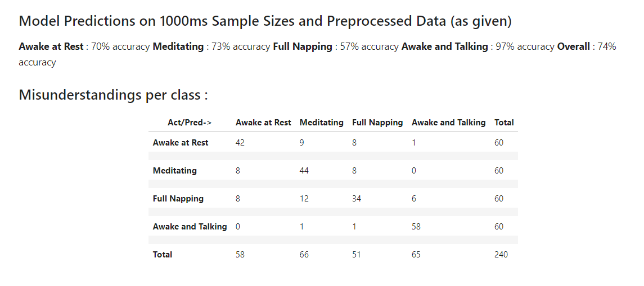

Sleep/Awake 158 22

Med 16 44

This is the confusion matrix if we pool the non-meditative states together.

**To-Do:**

1. Increase the training data
   1. We only took a small % of the preprocessed data(that is 20 mins of entire EEG recordings) as of now due to RAM crashing issues associated with loading the complete dataset. Steps in the direction towards solving this issue would be researched
2. Deepening the data preprocessing
   1. Need to explore the effects on the predictions that could be induced by following much layered preprocessing steps from the last project – Re-referencing, Baseline Correction, DC offset correction and Eye and Muscle Artifacts Removal.
3. Finding the right hyperparameters
   1. Currently we are only following the configuration of the model from the last project, however there is a need to explore and find a new set of hyperparameters that might best fit for this classification task
4. Getting into the frequency domain : put analysis into this